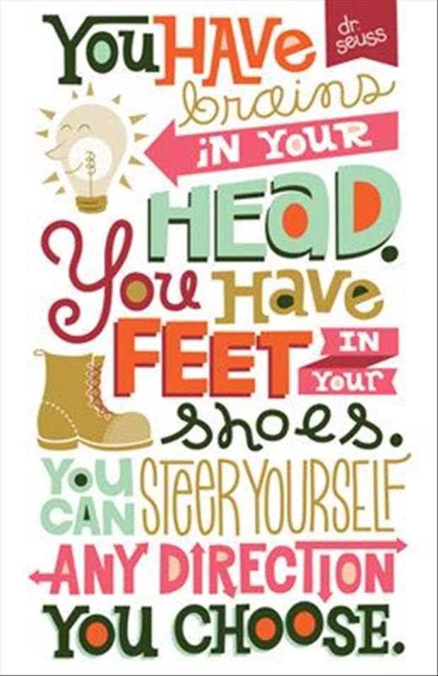
May 11, 2020
Parents and Students,

Hello everyone! It’s hard to believe that we are already at the last week of schoolwork. There are lots of fun activities to do this week.
Attached are the Assignment Instructions for the week of May 11
We’ll have a Zoom Meeting on Tuesday @ 10:00 am.
Contact me with any questions.
Ms. Hill

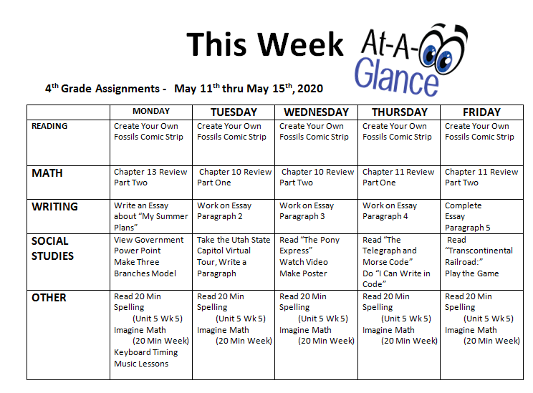
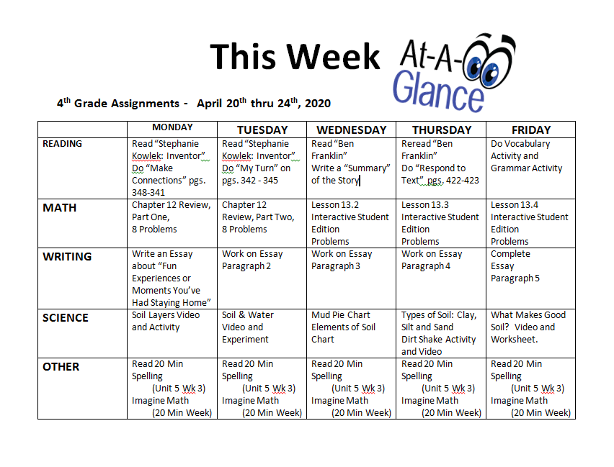
Monday, May 11, 2020
READING
Create Your Own Comic Strip About Fossils. (You will share your comic strip in a Zoom meeting on Friday, May 15th at 9:00 am).
email it to your teacher.
MATH
Use Clever to access Think Central with your Student ID and Password.
Complete Chapter 13 Review Part Two

WRITING
Monday through Friday of this week, Write an essay about “My Summer Plans.” You may use the “Hamburger Model” to organize your essay.

IMPORTANT: YOUR FINAL ESSAY MUST BE FIVE PARAGRAPHS LONG AND TYPED OR HANDWRITTEN ON A SEPARATE PIECE OF PAPER.

SCIENCE
View the Power Point, “Three Branches of Government” at this link: https://1drv.ms/p/s!AkLYILygRLYxi16V0jaI1j-QTYlG?e=u3oY8y
Make your own Tree Model of the Three Branches of Government.
Take a picture of your completed model and email it to your teacher.

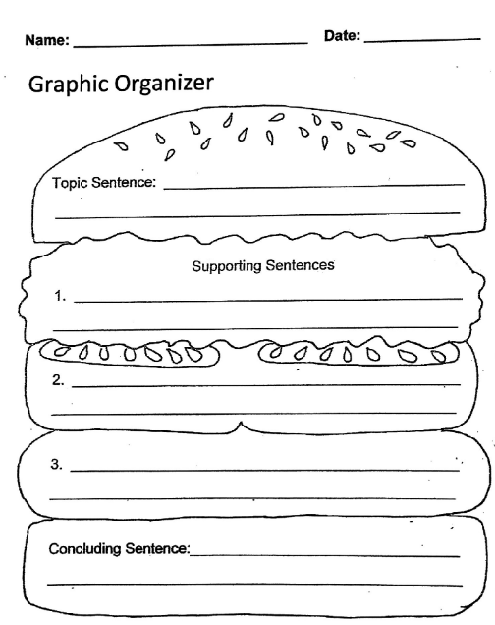
This is for planning your essay ONLY. Your final essay must be five complete paragraphs, written or typed on a separate piece of paper!

Create Your Own Comic Strip
Directions: This week for Language you will create a comic strip about fossils. Make sure to include characters, setting, dialogue, and the beginning, middle, and ending of the story. You may use the templates provided or you may draw your own.
Vocabulary:
Dialogue - when at least two characters are talking to each other in a conversational format.
Setting - where a story or event takes place. Authors can describe a setting to include geographic location, time, weather, and environment.
Mandible - lower jaw or jawbone
Anticlimactic – when something disappointing or "boring" happens.
Paleontologist - Scientists who study the remains of these ancient organisms, or living things.
Jaw-dropping – an idiom that means something is extremely surprising, impressive, or shocking.

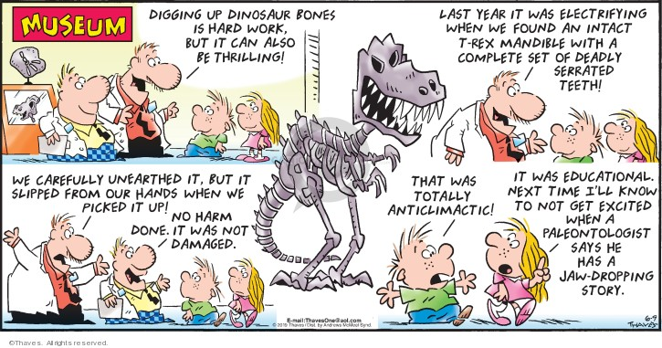
Example:

Name: ______________________________________

Plan Your Comic Strip

Characters:______________________________________________________________________________________________________________________________________________________

Setting: ______________________________________________
_____________________________________________________

Dialogue:________________________________________________________________________________________________________________________________________________________

Beginning: ____________________________________________

Middle: _______________________________________________

End: ________________________________________________

Name: ___________________________

Title: _______________________________________________
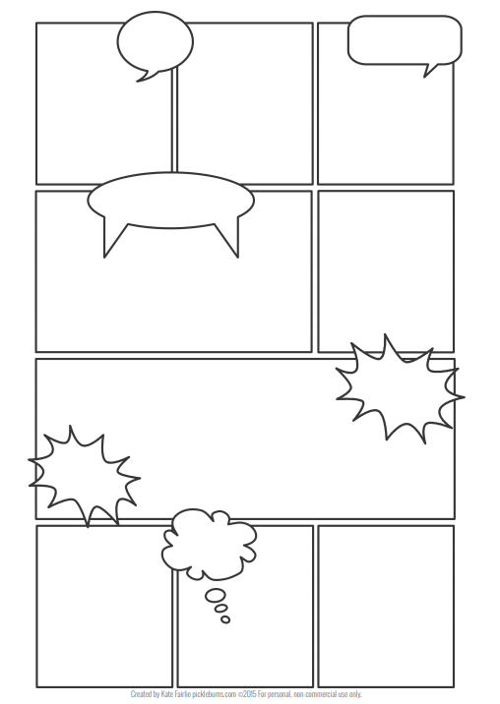

Name: ___________________________

Title: _______________________________________________
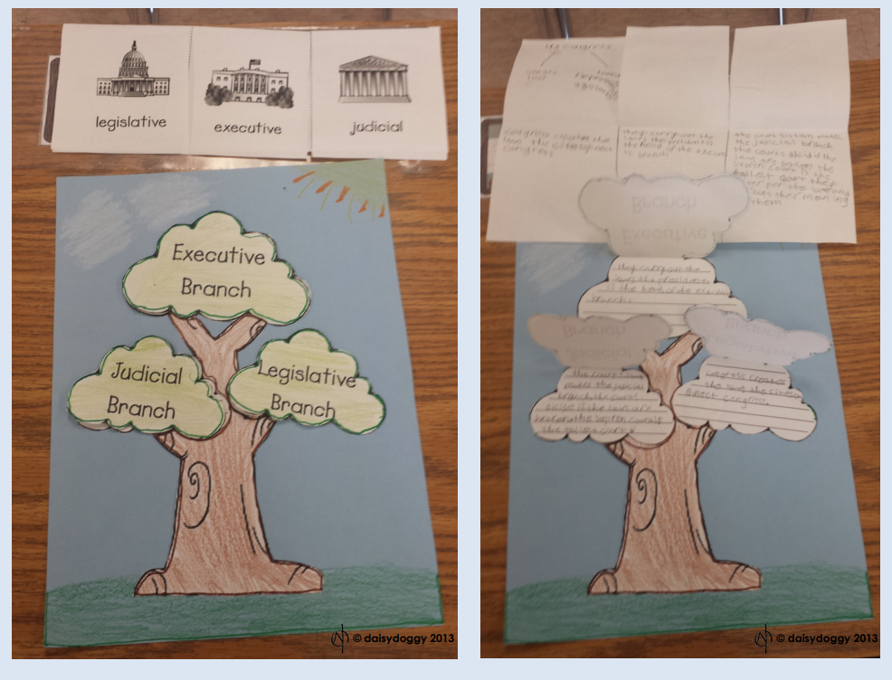
Model of the Three Branches of Government
Use the Power Point to find the definition of each branch of government.
Write the definitions on the lined sections of the model.
Color and cut out the pieces.
Glue them together with the correct Branch title over its definition.
(If you don’t have access to a printer you can draw the tree yourself).

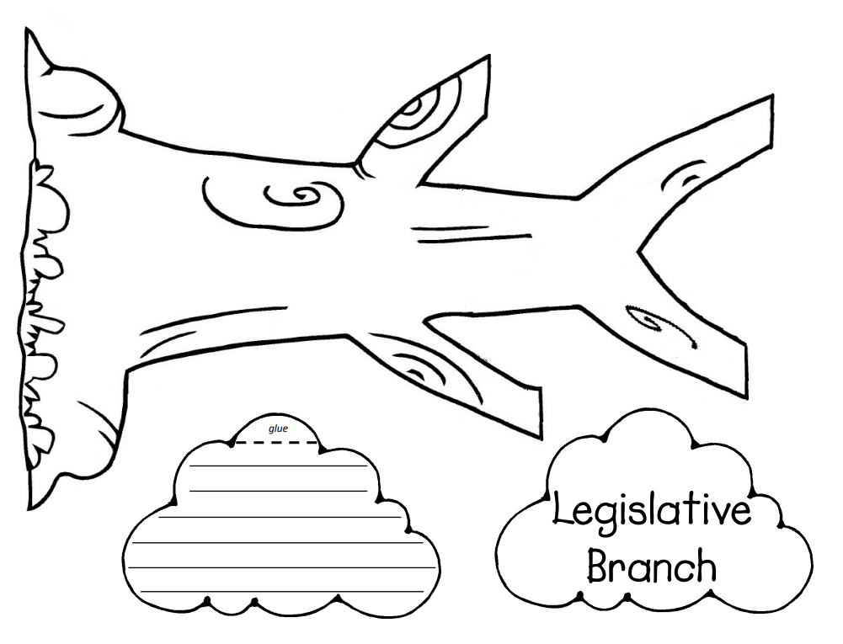

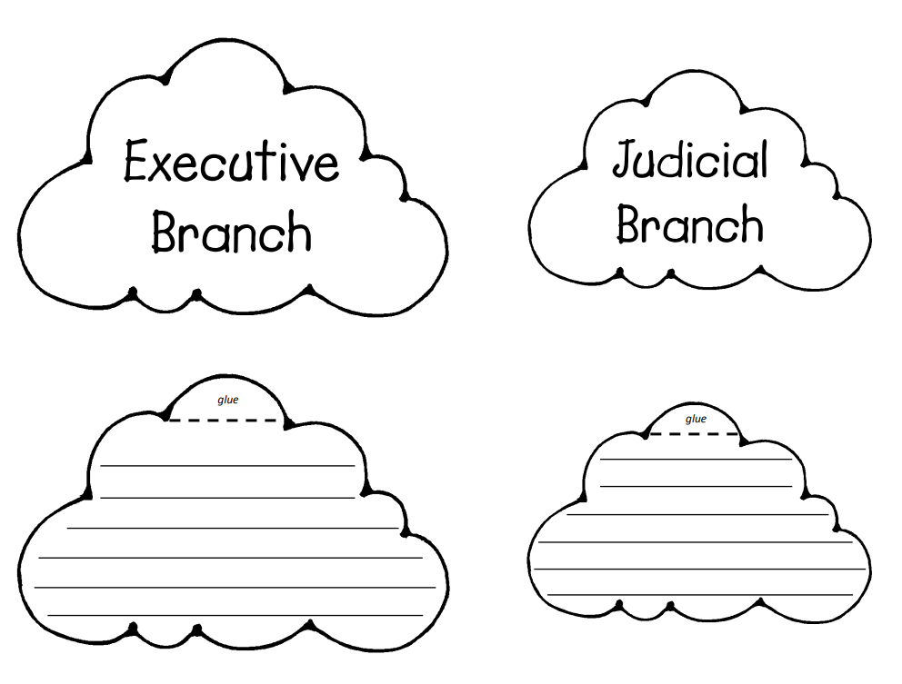
Tuesday, May 12, 2020
READING
Create Your Own Comic Strip About Fossils. (You will share your comic strip in a Zoom meeting on Friday, May 15th at 9:00 am).
email it to your teacher.
MATH
Use Clever to access Think Central with your Student ID and Password.
Complete Chapter 10 Review Part One

WRITING
Monday through Friday of this week, Write an essay about “My Summer Plans.” You may use the “Hamburger Model” to organize your essay.

IMPORTANT: YOUR FINAL ESSAY MUST BE FIVE PARAGRAPHS LONG AND TYPED OR HANDWRITTEN ON A SEPARATE PIECE OF PAPER.

SCIENCE
Use this link to take a virtual tour of the Utah State Capitol. Use the controls and explore and find as many things as you can. https://www.utah.gov/capitol-tour/
Write a paragraph about your tour of the Capitol
Email the paragraph to your teacher.

Name: ___________________________________

All About My Tour
__________________________________________________________________________________________________________________________________________________________________________________________________________________________________________________________________________________________________________________________________________________________________________________________________________________________________________________________________________________________________________________________________________________________________________________________________________________________________________________________________________________________________________________________________________________________________________________________________________________________________________
Wednesday, May 13, 2020
READING
Create Your Own Comic Strip About Fossils. (You will share your comic strip in a Zoom meeting on Friday, May 15th at 9:00 am).
email it to your teacher.
MATH
Use Clever to access Think Central with your Student ID and Password.
Complete Chapter 10 Review Part Two

WRITING
Monday through Friday of this week, Write an essay about “My Summer Plans.” You may use the “Hamburger Model” to organize your essay.

IMPORTANT: YOUR FINAL ESSAY MUST BE FIVE PARAGRAPHS LONG AND TYPED OR HANDWRITTEN ON A SEPARATE PIECE OF PAPER.

SCIENCE
Read the Passage “The Pony Express”
Watch this Video: https://youtu.be/cUvyjjNbNOk
Design and Color your own Pony Express Poster and take a photo of it.
Email the photo to your teacher.

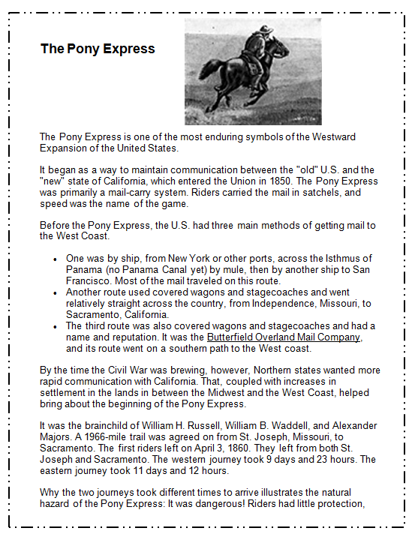

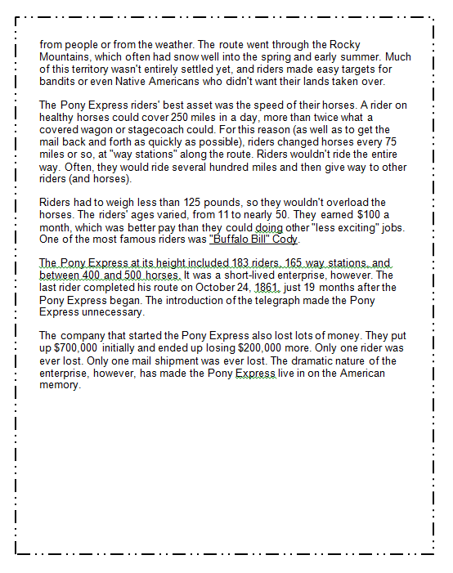

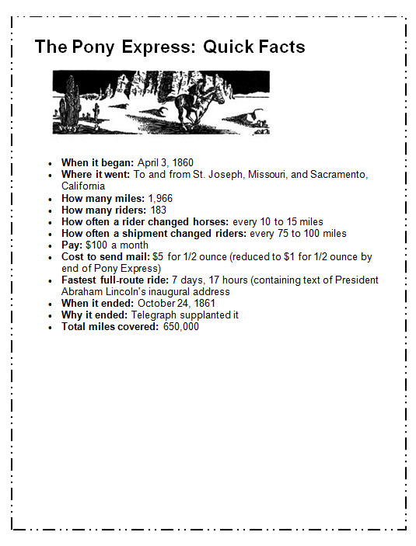

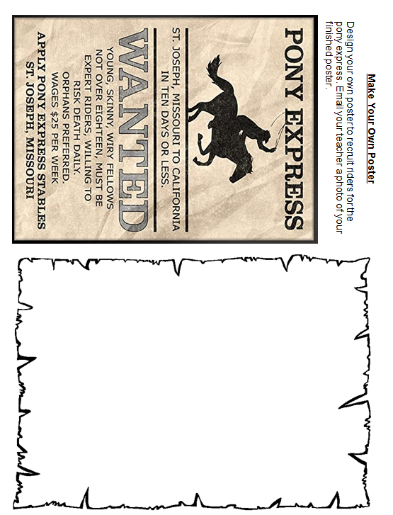

Thursday, May 14, 2020
READING
Create Your Own Comic Strip About Fossils. (You will share your comic strip in a Zoom meeting on Friday, May 15th at 9:00 am).
email it to your teacher.
MATH
Use Clever to access Think Central with your Student ID and Password.
Complete Chapter 11 Review Part One

WRITING
Monday through Friday of this week, Write an essay about “My Summer Plans.” You may use the “Hamburger Model” to organize your essay.

IMPORTANT: YOUR FINAL ESSAY MUST BE FIVE PARAGRAPHS LONG AND TYPED OR HANDWRITTEN ON A SEPARATE PIECE OF PAPER.

SCIENCE
Read the Passage “The Telegraph and Morse Code”
Complete the page “I Can Write in Code”
Email the photo to your teacher.

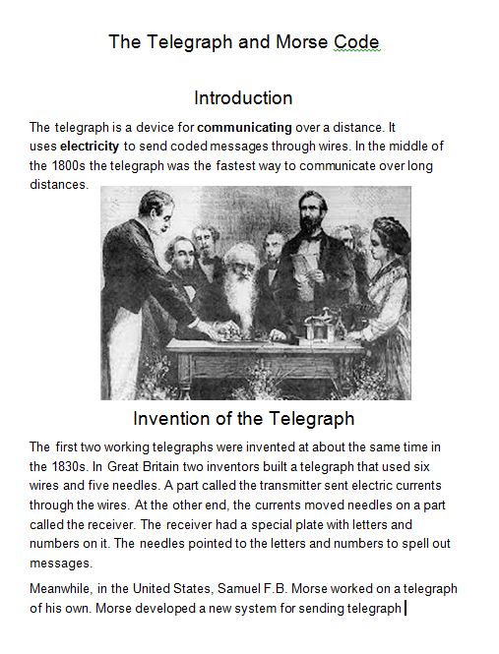

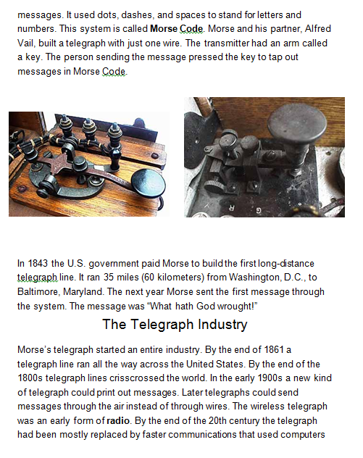

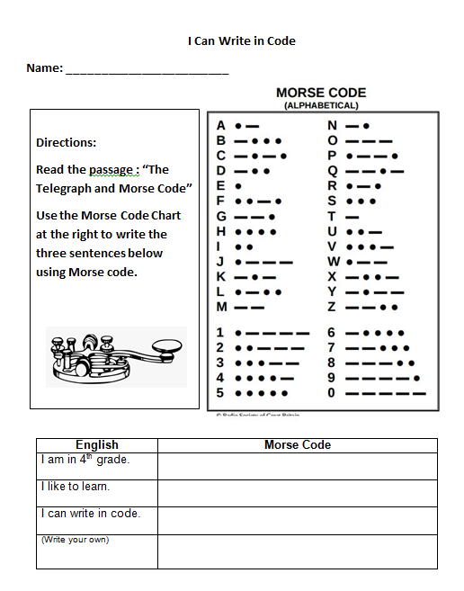

Friday, May 15, 2020
READING
Create Your Own Comic Strip About Fossils. (You will share your comic strip in a Zoom meeting on Friday, May 15th at 9:00 am).
email it to your teacher.
MATH
Use Clever to access Think Central with your Student ID and Password.
Complete Chapter 11 Review Part Two

WRITING
Monday through Friday of this week, Write an essay about “My Summer Plans.” You may use the “Hamburger Model” to organize your essay.

IMPORTANT: YOUR FINAL ESSAY MUST BE FIVE PARAGRAPHS LONG AND TYPED OR HANDWRITTEN ON A SEPARATE PIECE OF PAPER.

SCIENCE
Read the Passage “Transcontinental Railroad”
Watch the Video “The Transcontinental Railroad and the American West”
https://www.youtube.com/watch?v=0CdAzizWiyI&list=PLUNnV_PBF5eoIvcGEkVGEuoXW83ZL-Stv&index=27&t=5s
Play the Game, take a Photo.
Email the photo to your teacher.

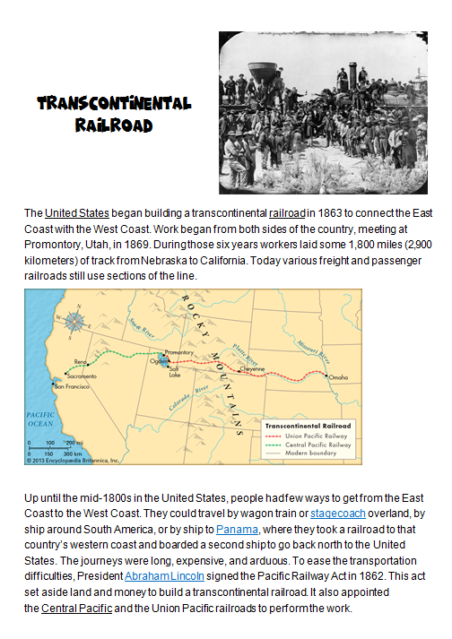

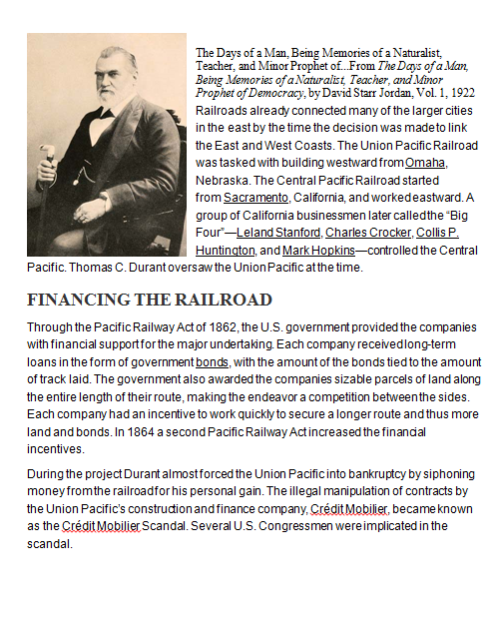

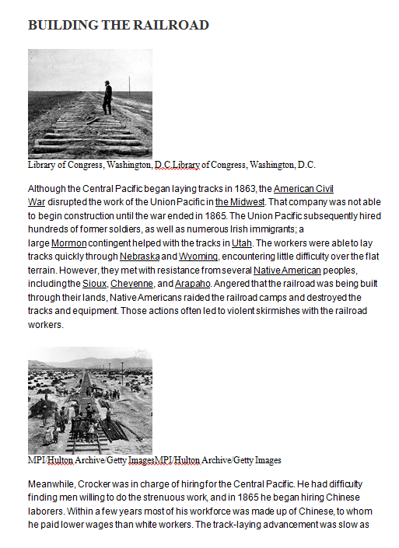

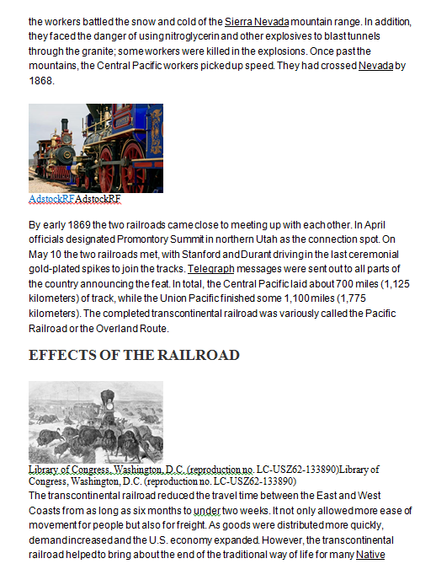

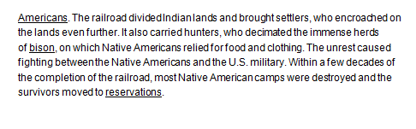

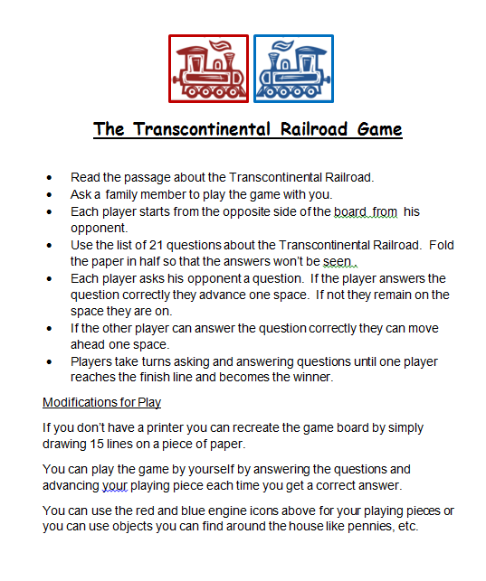

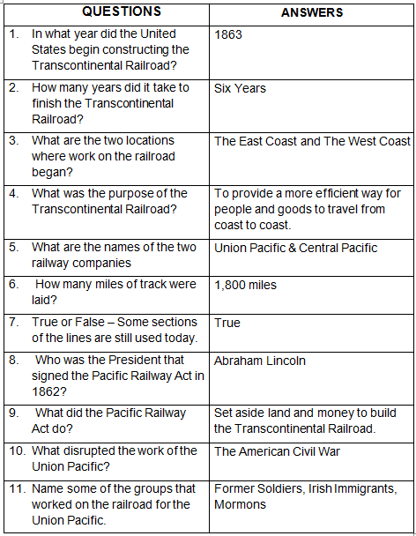

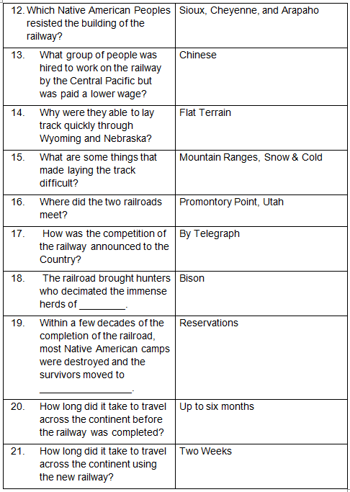

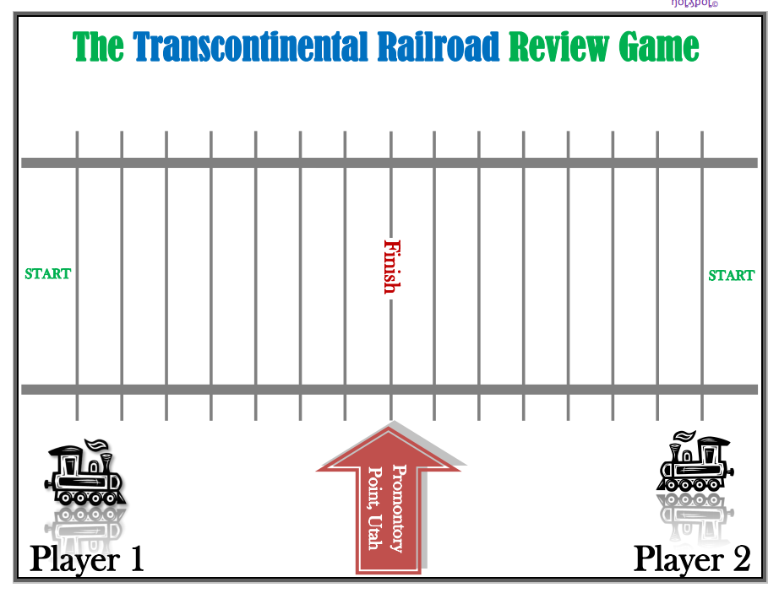
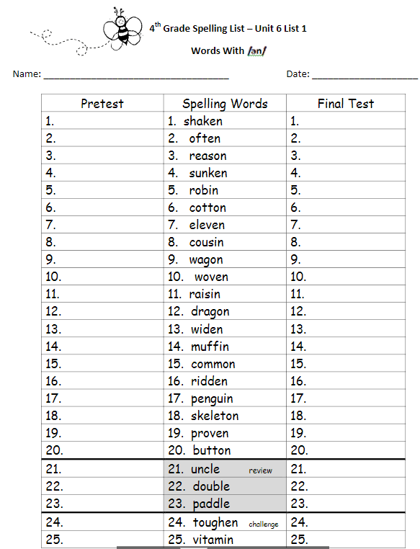

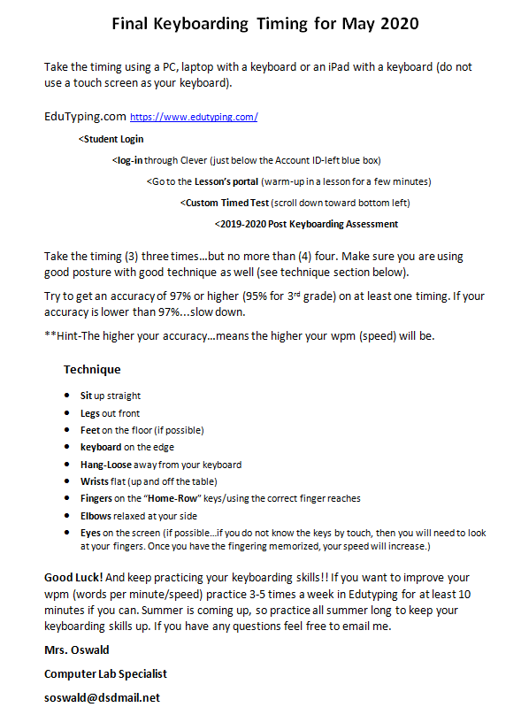

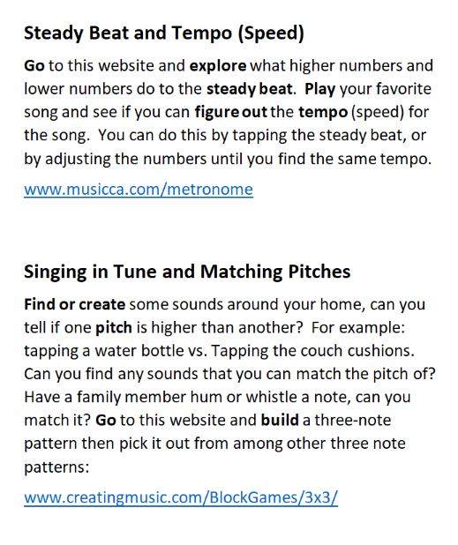
Music Lesson

