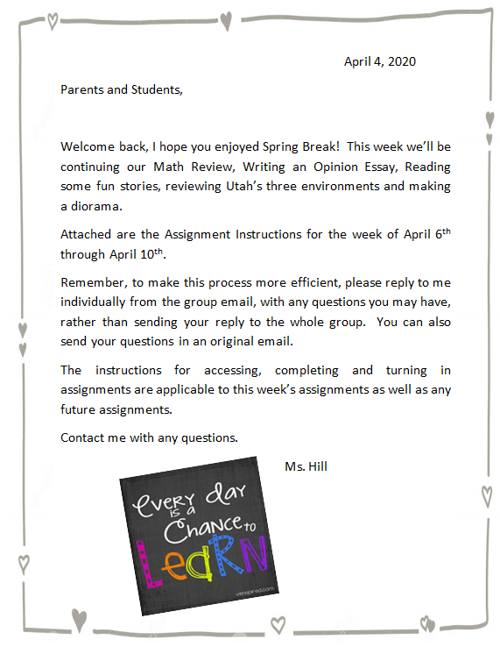
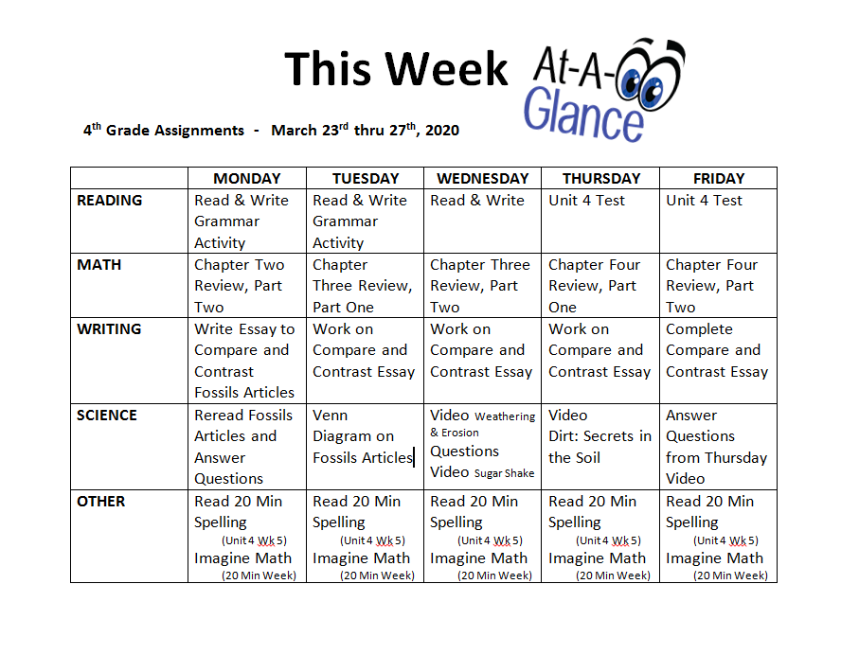

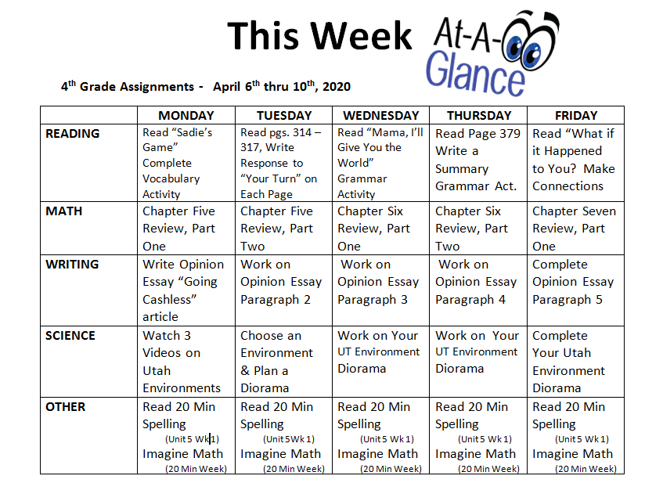

Monday, April 6, 2020
READING
Use Clever to access McGraw-Hill with your Student ID and Password
Read "Sadie's Game" on pages 310 -313, Complete Monday’s Grammar Activity. Email written assignments to Ms. Hill.
MATH
Use Clever to access Think Central with your Student ID and Password.
Under “To Do” complete Chapter Five Review, Part One, questions. Use paper to find the answers and show your work whenever possible.
WRITING
Read Going Cashless .
Monday through Friday of this week, Write an essay giving your opinion of the article (One paragraph each day). You may use the “Hamburger Model” to organize your essay.

IMPORTANT: YOUR FINAL ESSAY MUST BE FIVE PARAGRAPHS LONG AND TYPED OR HANDWRITTEN ON A SEPARATE PIECE OF PAPER.

SCIENCE
Watch these three videos on the Davis School District site at Safari Montage
Utah’s Deserts - https://media.davis.k12.ut.us/?g=4d238a0a-6fa7-11ea-b8db-ecf4bbe6ca64
Utah’s Wetlands - https://media.davis.k12.ut.us/?g=af27d6b4-6fa8-11ea-b8db-ecf4bbe6ca64
Utah’s Forests - https://media.davis.k12.ut.us/?g=89820b3c-6fa9-11ea-b8db-ecf4bbe6ca64

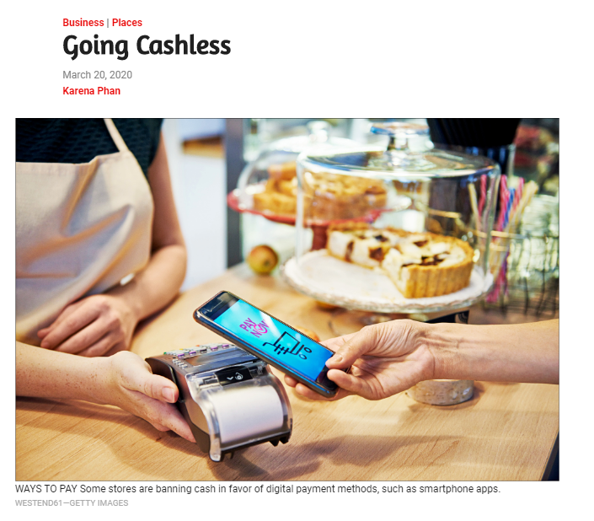
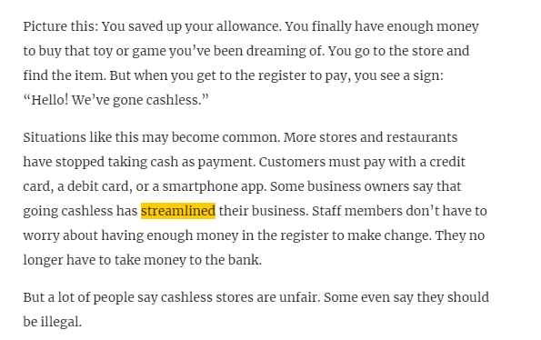
https://www.timeforkids.com/g34/going-cashless/
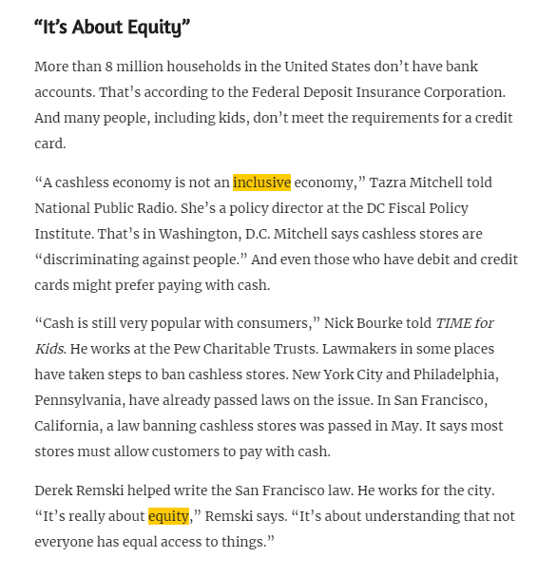

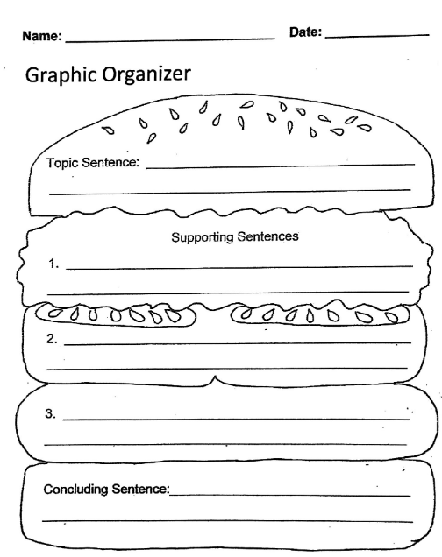
This is for planning your essay ONLY. Your final essay must be five complete paragraphs, written or typed on a separate piece of paper!
Tuesday, April 7, 2020
READING
Use Clever to access McGraw-Hill with your Student ID and Password
Read pages 314 – 317 (Sadie’s Game), Write your responses to "Your Turn" from each page.
Email written assignments to Ms. Hill.

MATH
Use Clever to access Think Central with your Student ID and Password.
Under “To Do” complete Chapter Five Review, Part Two. Use paper to find the answers and show your work whenever possible.

WRITING
Work on writing your Opinion Essay about “Going Cashless.”
Complete paragraph two.

SCIENCE
Read attached page about Utah’s Three Environments and Diorama Instructions
Choose and Environment and Begin Planning your own Diorama

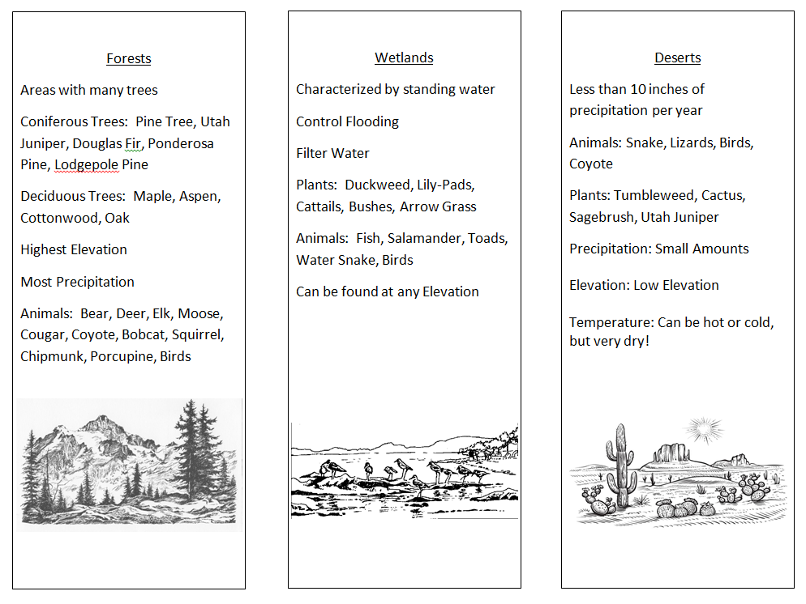
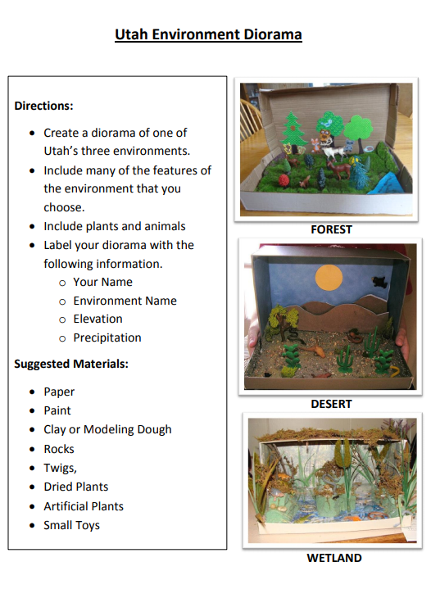

Wednesday, April 8, 2020
READING
Read “Mama, I’ll Give You the World” on pages 362 - 379
Complete Wednesday’s Grammar Activity
Email written assignments to Ms. Hill.

MATH
Use Clever to access Think Central with your Student ID and Password.
Under “To Do” complete Chapter Six Review, Part One. Use paper to find the answers and show your work whenever possible.

WRITING
Work on writing your Opinion Essay about “Going Cashless.”
Complete paragraph three.

SCIENCE
Work on your Diorama of a Utah Environment.
Thursday, April 9, 2020
READING
Use Clever to access McGraw-Hill with your Student ID and Password
Write a summary of “Mama, I’ll Give You the World”, use a “Problem and Solution Chart” like the one on page 379 to help you.
Complete Thursday’s Grammar Activity
Email written assignments to Ms. Hill.
MATH
Use Clever to access Think Central with your Student ID and Password.
Under “To Do” complete Chapter Six Review, Part Two. Use paper to find the answers and show your work whenever possible.

WRITING
Work on writing your Opinion Essay about “Going Cashless.”
Complete paragraph four.

SCIENCE
Work on your Diorama of a Utah Environment.
Friday, April 10, 2020
READING
Use Clever to access McGraw-Hill with your Student ID and Password
Read “What if it Happened to You?” pages 380 – 383
Write your answer to “Make Connections” on page 383.
Email written assignments to Ms. Hill.
MATH
Use Clever to access Think Central with your Student ID and Password.
Under “To Do” complete Chapter Seven Review, Part One. Use paper to find the answers and show your work whenever possible.

WRITING
Complete your Opinion Essay about “Going Cashless.”
Complete paragraph five.
Email completed essay to Ms. Hill

SCIENCE
Complete Work on your Diorama of a Utah Environment.
Take a photo and email it to Ms. Hill.

